**NETWORKING & SYSTEM ADMINISTRATION LAB**

**Name: Sanio Luke Sebastian**

**Roll No: 35**

**Batch: B**

**Date: 23-05-2022**

**Experiment No.: 12**

**Aim**

Installation of Docker in Ubuntu.

**Procedure**

* **Installation of DOCKER**

1. Open the terminal on Ubuntu.
2. Remove any Docker files that are running in the system, using the following command:

**$ sudo apt-get remove docker docker-engine docker.io**

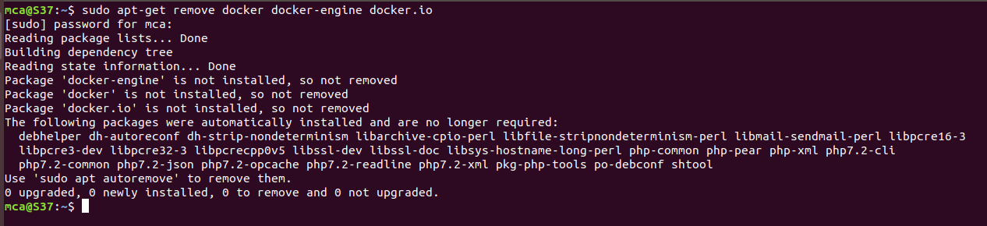

After entering the above command, you will need to enter the password of the root and press enter.

1. Check if the system is up-to-date using the following command:

**$ sudo apt-get update**

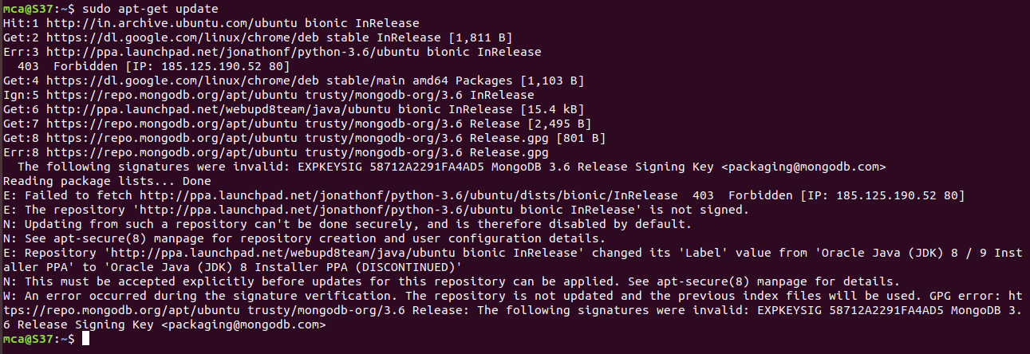

1. Install Docker using the following command:

**$ sudo apt install docker.io**

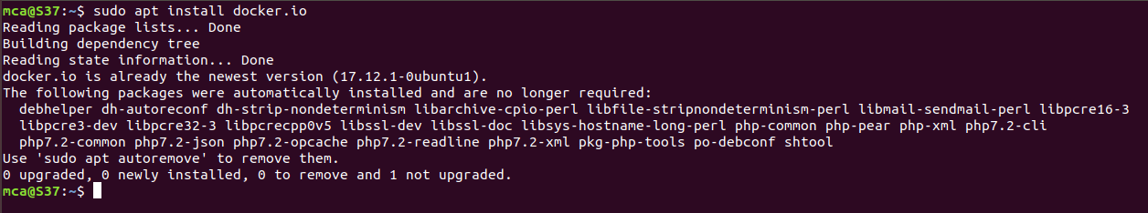

You’ll then get a prompt asking you to choose between y/n - choose *y*

1. Install all the dependency packages using the following command:

**$ sudo snap install docker**

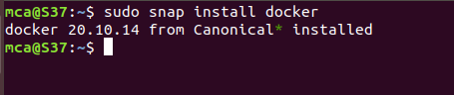

1. Before testing Docker, check the version installed using the following command:

**$ docker --version**

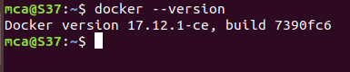

1. Pull an image from the Docker hub using the following command:

**$ sudo docker run hello-world**

Here, *hello-world* is the docker image present on the Docker hub.

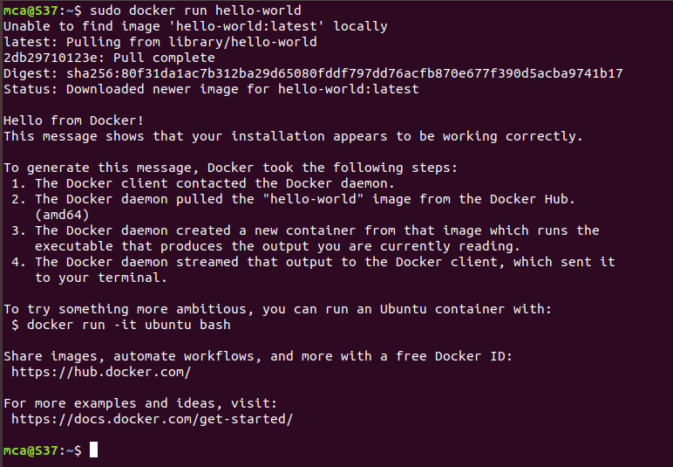

1. Check if the docker image has been pulled and is present in your system using the following command:

**$ sudo docker images**

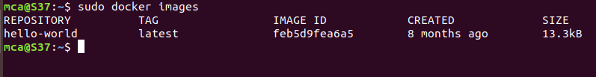

1. To display all the containers pulled, use the following command:

**$ sudo docker ps -a**



1. To check for containers in a running state, use the following command:

**$ sudo docker ps**



1. You’ve just successfully installed Docker on Ubuntu.

* **Setting up an APACHE Container**

To setup the apache container, we have to pull apache container from the docker and its image too. For that, we have to perform various commands and restart the docker to run the apache container.

* + - 1. Pull the Docker Apache Container.

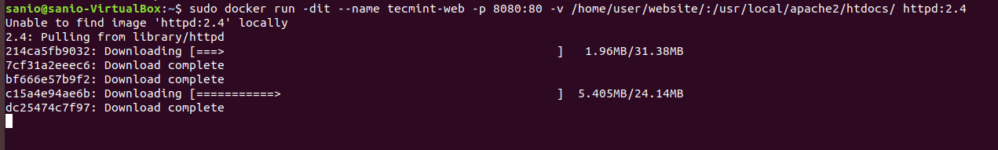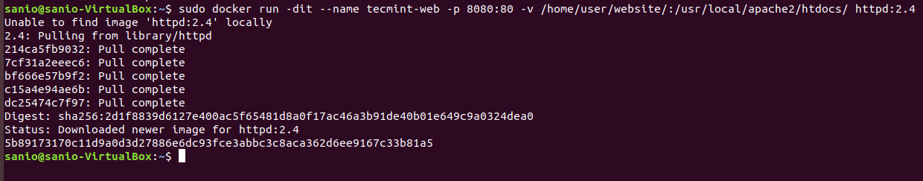

At this point, our Apache container should be up and running.

* + - 1. Check Apache Docker Container to verify the successful pull of the apache container.



* + - 1. Now let’s create a simple web page named docker.html inside the /home/user/website directory.

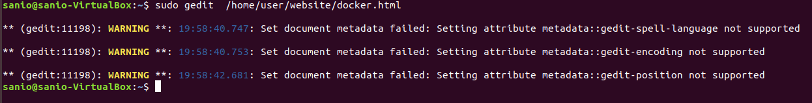

Add the following sample HTML content to the file.

<!DOCTYPE html>

<html lang="en">

<head>

<meta charset="UTF-8">

<title>Learn Docker at Tecmint.com</title>

</head>

<body>

<h1>Learn Docker With Us</h1>

</body>

</html>

Next, point your browser to Server-IP**: 8080/docker.html**. You should be presented with the page we created previously.

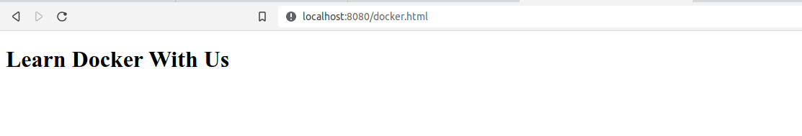

* + - 1. Check Apache Page and If you wish, you can now stop the container by using the command below:

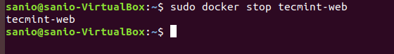

* + - 1. Also the container can be removed using the command below:

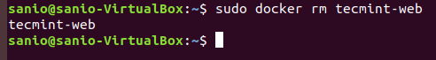

* + - 1. To finish up the deletion of the container and clean up, you may want to delete the image that was used in the container by using the below command:

